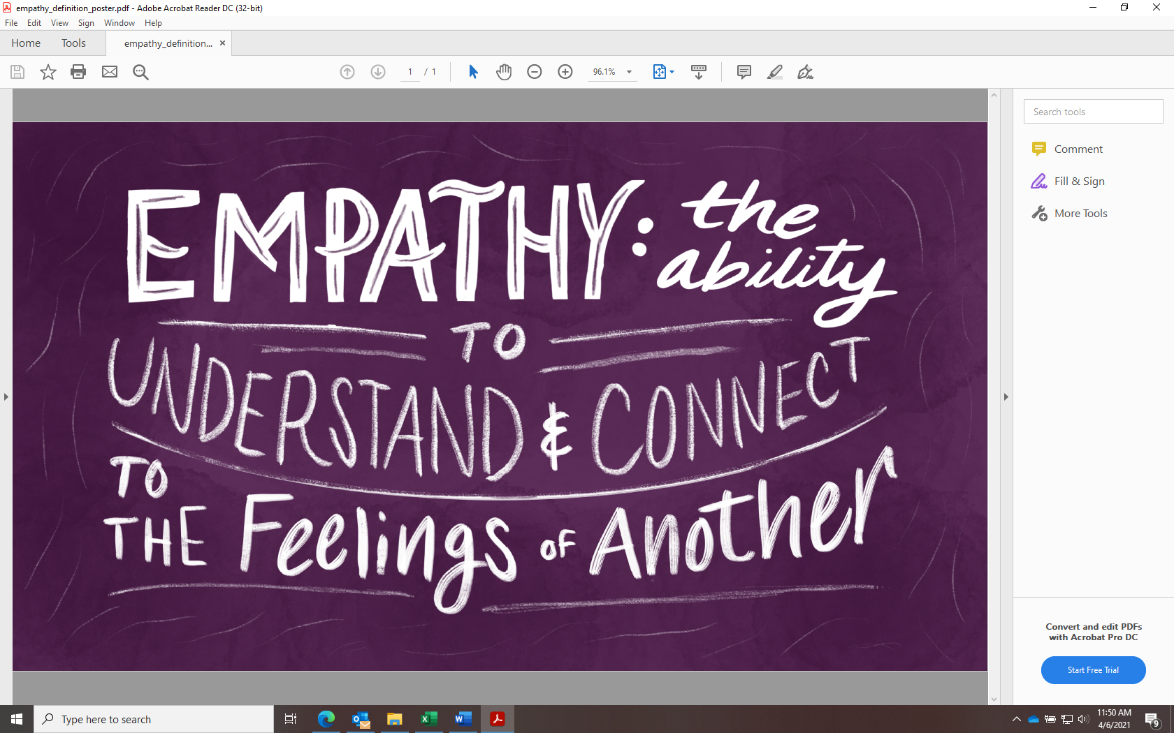

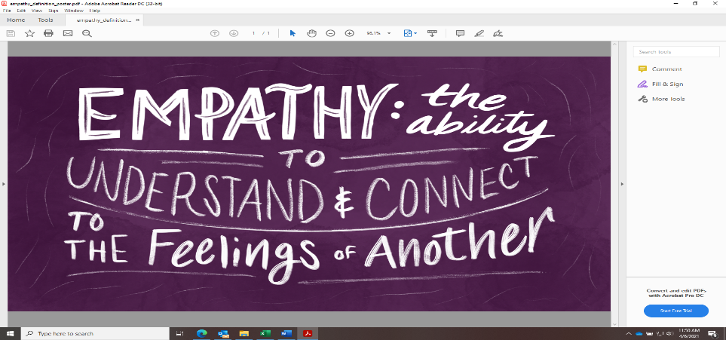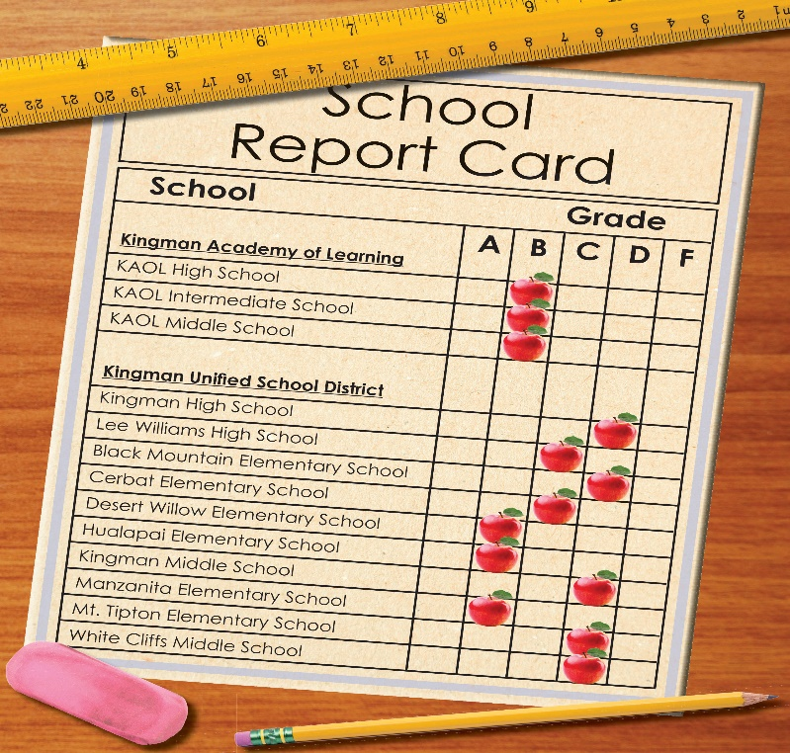

Our Character Strong Trait will switch to Responsibility on April 19th – May 7th

**SPRING FUNDRAISER**

Today your students are bringing home their sample for our latest fundraiser!!

Such Beautiful All Occasion Cards created by your very own!!

Simply follow the instructions inside the card to place your order. Feel free to share this with family & friends! If you are unable to order online, please contact Miss Robyn at 392-5124.

**Order Deadline – Sunday, April 18th!**

**No School for Students**

**Wednesday, April 14**

**AM: Parent Teacher Interviews**

**PM: School Based Professional Learning**

April 22, 2021

EYE-DA Testing for PRE-K

(if you know of anyone who hasn’t registered for Kindergarten, please let them know to contact the school!)

Parent Teacher Interviews will be Tuesday, April 13th 3:30-7:00 and the morning of Wednesday, April 14th 8:30 – 11:30. Parent teacher will take place via phone call or virtual meeting. Please contact Miss Robyn at

392-5124 to book your time slot.

**This month our Character Strong Trait is Empathy. We are encouraging the children understand others’ feelings!**

**BRISTOL BULLDOGS’ BULLETIN**

**April 2021 Publication**

**BRISTOL ELEMENTARY SCHOOL**

**\*\*\*third edition\*\*\***

Phone 392-5124

Website: [Pages - Home (nbed.nb.ca)](https://secure1.nbed.nb.ca/sites/ASD-W/bres/Pages/default.aspx)

Facebook: <https://www.facebook.com/Bristol-Elementary-School-164173490834603>